INSTRUCTION TO FLASH STM32 ON EZLO AWARE

There are two methods in Ezlo Aware for flashing the STM32 DSP Microcontroller and receiving sound input. Both methods are listed below

Flash using ST-LINK/V2
- Download and install STM32CubeIDE and STM32CubeProgrammer from official website
- Connect the probes from ST-LINK/V2 debugger in manner as shown in the image below:
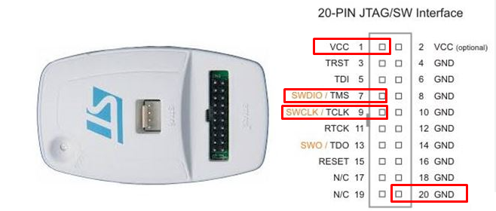
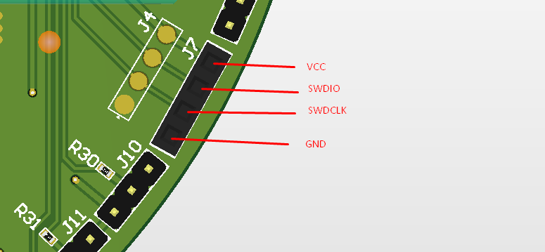
- Once the connections are made and verified, open STM32CubeProgrammer and choose ST-LINK from Top Right corner of the screen.
- Refresh the Serial Number section in ST-Link Configuration menu and select your ST-LINK
- Port should be SWD, Frequency should be 4000KHz, Reset Mode should be Software Reset. Rest of the options can be left default
- Click Connect to connect to the ST-Link Debugger and verify successful connection.
- Click on Download button on the left corner of the screen. This will open Erasing and Programming menu.
- Select binary .elf file from the browse menu. Check mark Verify Programming and click Start Program to start flashing.
- Once successful, reboot Ezlo Aware and observe Sound UI Tile behavior.

Flash using USB Cable
- There is also a capability to flash binary using USB Serial bootloader. In order to do this, take a standard USB cable and tear it from one end to expose the wires. Then make connections with Ezlo Aware as shown below:
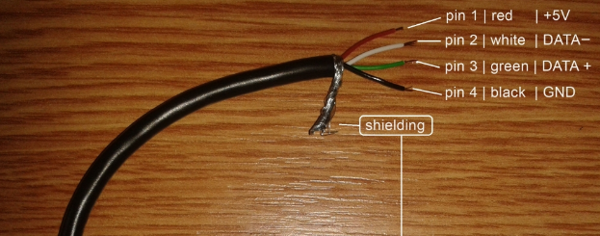
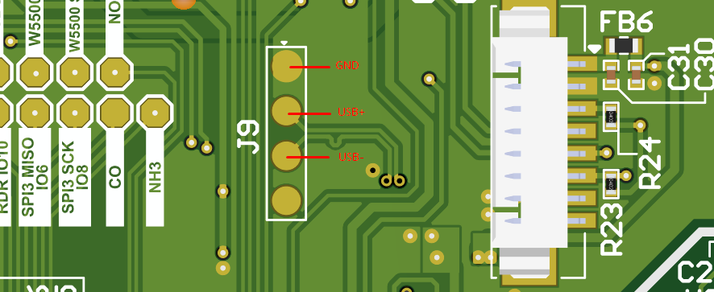
- Once connected, make the following jumper connections as shown below and reboot the board after making the jumper connections on J10 and J11:
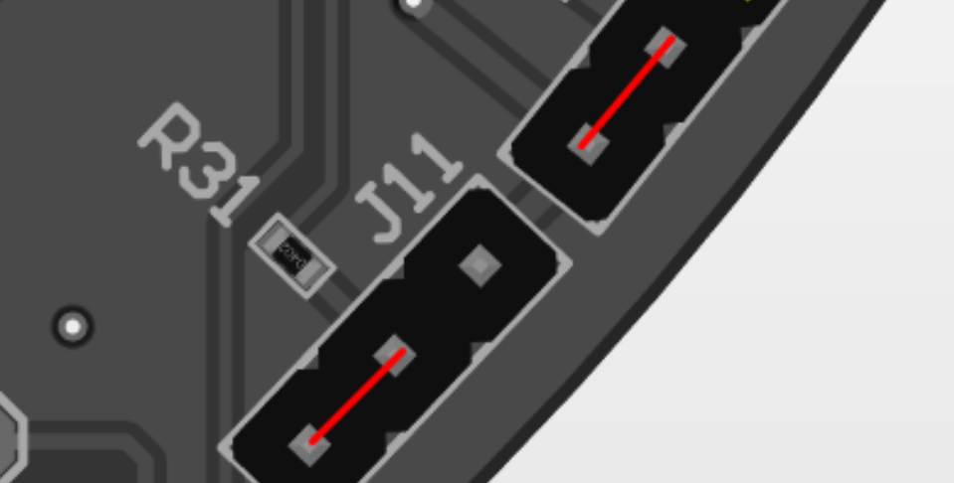
- When rebooted, the device will appear as USB DFU in device manager. Now select USB option instead of ST-LINK option in ST32CubeProgrammer and repeat all the steps from Method No. 1 Points f to h.
- Once successful programming is done, disconnect power and make jumper connections now as shown below

- Re-apply power to the Ezlo Aware and it should appear as COM Device this time.
- Observe Sound UI Tile behavior.

